Ideation Phase
Brainstorm & Idea Prioritization Template

Date:31 January 2025
Team ID:LTVIP2026TMIDS91486
Project Name:HematoVision – Advanced Blood Cell Classification Using Transfer Learning
Maximum Marks:4 Marks

Brainstorm & Idea Prioritization Template:
Brainstorming provides a free and open environment that encourages team members to participate in the creative thinking process that leads to effective problem solving. Prioritizing volume over value, diverse ideas are generated, evaluated, and refined collaboratively.
This template is used to structure idea generation and selection for the HematoVision project.

Step-1: Team Gathering, Collaboration and Selection of Problem Statement 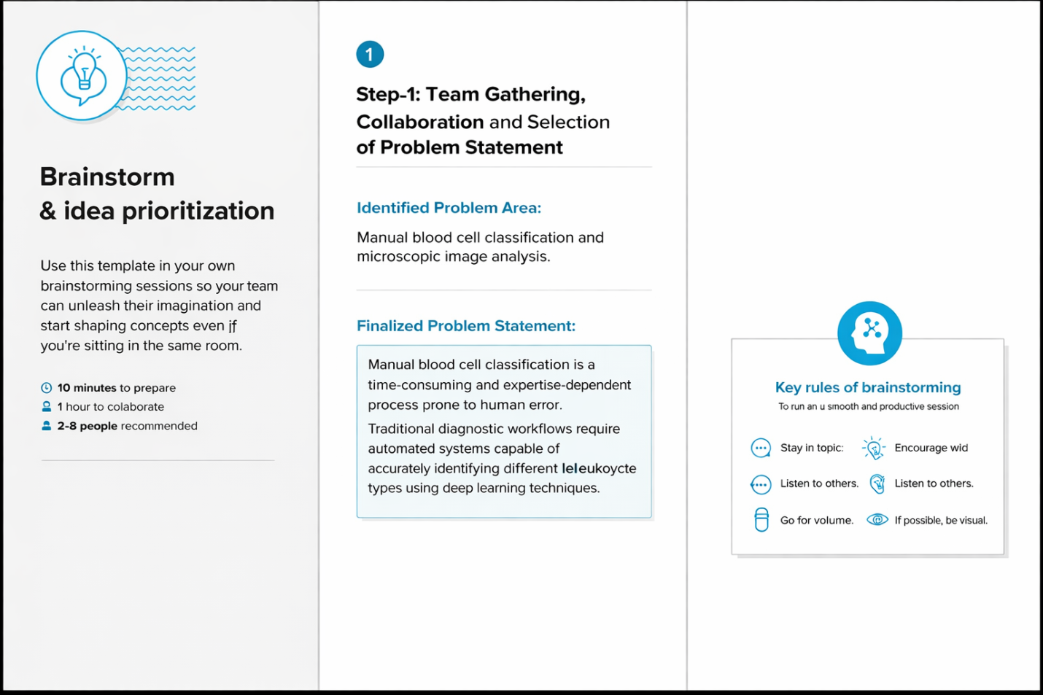

Step-2: Brainstorming, Idea Listing and Grouping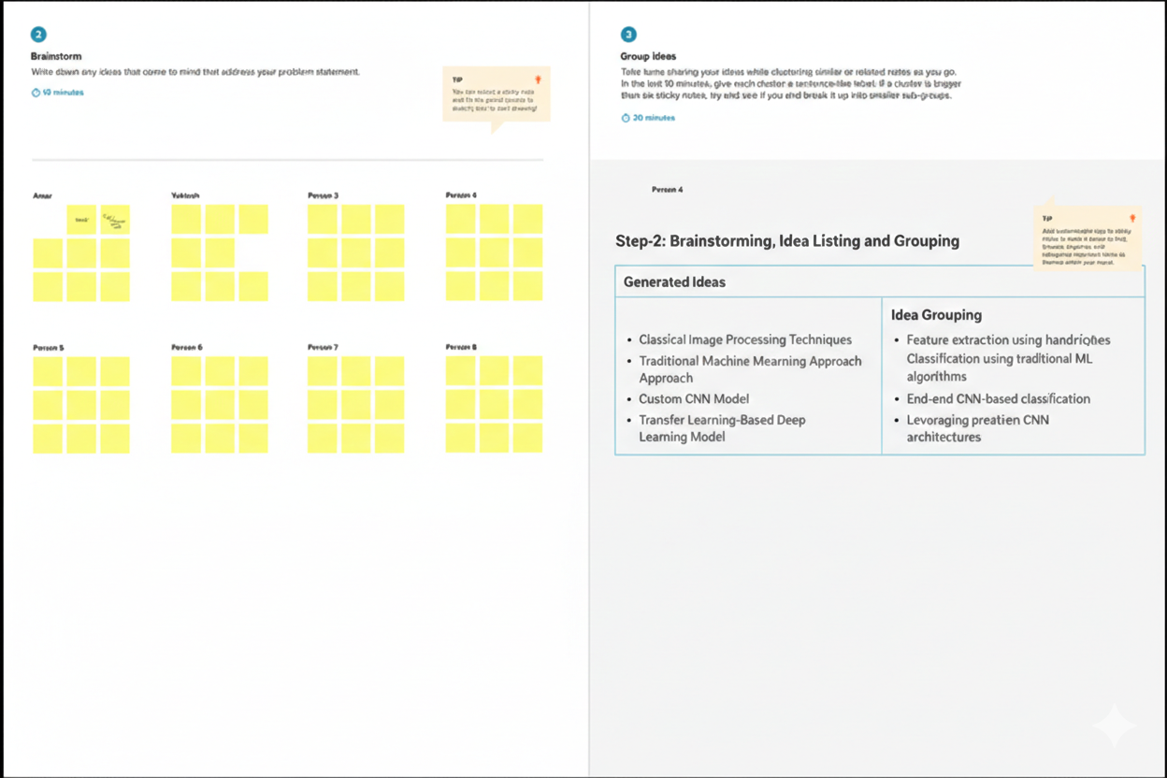 Step-3: Idea Prioritization

